Brno Museum Night 2011
Saturday 14. 5. 2011
18.00–24.00
www.brnenskamuzejninoc.cz
press release of 8. 4. 2011

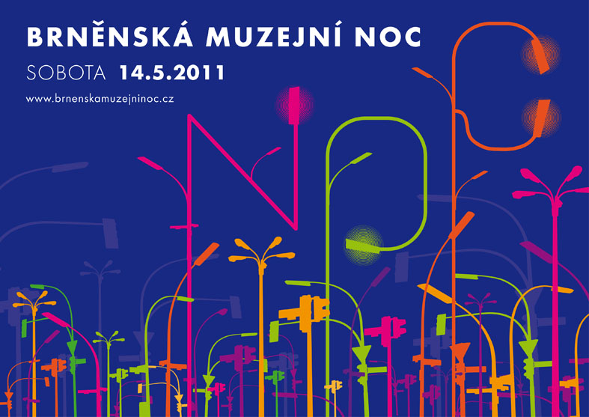

This year’s Brno Museum Night is going to be held for the seventh time and takes place on Saturday, 14th May. In view of the previous successful events we are convinced that it has become a brand that needs no introduction. Almost everybody in and around Brno knows that the phenomenon of the Brno Museum Night encompasses free guided tours of permanent exhibitions after dark, dozens of attractive temporary exhibitions, art workshops, lectures, concerts, theatre performances, food and beverage tasting, examples of handicrafts, fashion shows and much more. However, each year manages to offer something new with the potential to pleasantly surprise. Apart from the rich cultural programme the organizers are again searching for a way of how to exploit the potential of the Brno Museum Night for the rest of the year. We will do our best to receive feedback from our work and what we provide in terms of free-time activities.
Marek Pokorný, director of the Moravian Gallery in Brno, which for the third time has taken on responsibility for managing the whole event, adds: “Every year during the Museum Night we do our best to show people that we have something to offer not just once in a year but almost every day. However, there are no significant increases in the number of regular visitors to the galleries. We would like to find out why. What can we do so that people would visit exhibitions more often? In what way might the galleries and museums deter and, on the contrary, attract visitors? We do care about the opinion of the public. We feel sure that it can help us to improve.”
Visitors to the Brno Museum Night can voice their opinion by means of a questionnaire (printed or electronic) and a special area will be reserved for this purpose in each of the participating buildings. Another option of giving comments is available to facebook users on the official page of the Brno Museum Night at http://www.facebook.com/brnenskamuzejninoc and the public can also share their views thanks to the Brno Museum Night Check-in. It is being developed by Martin Hassman and Marek Lutonský on the request of the the Moravian Gallery in Brno. Visitors will be able to check-in at more than thirty locations with exhibitions and cultural programmes. For those who have never checked in before and would like to give it a try for the first time on Saturday 14th May, the Brno Museum Night Check-in web page at http://www.facebook.com/brnenskamuzejninoc#!/brnoc will provide detailed instructions for working with both the Foursquare and Gowall applications. People will have a chance to be informed in real time at which museum their friends are at that very moment and what they like there.

The fifteen organizers of the Brno Museum Night have been joined this year for the first time by a guest — the National Theatre Brno. The Brno Museum Night has already served as inspiration for similar events (e.g. the Night of Churches), and it is not impossible that the theatre might use the experience gained this year to organise an event of its own. There is also something new from the Brno branch of the National Heritage Monument Institute which has also decided to open to the public the traditional Galerie Sklepení in the city centre along with the Vila Stiassni on Hroznová St. in Pisárky. The programme of the Brno Observatory and Planetarium can be seen only in the Jiří Mahen Library on Kobližná and in Špilberk Castle as the observatory building on top of Kraví hora is closed due to reconstruction. However, thanks to the completion of the upgrade of Moravské náměstí visitors to the Brno Museum Night will again be able to walk into the Governor’s Palace of the Moravian Gallery in Brno.
A detailed programme of the Brno Museum Night, information regarding its organization, as well as the latest updates and news from the preparations can be found throughout April at www.brnenskamuzejninoc.cz. April is also the month when the programme brochures will go to print and a week before the event an information bus will again park in náměstí Svobody in Brno.

The Brno Museum Night is held under the auspices of Roman Onderka, the mayor of the City of Brno, Michal Hašek, the head of the South Moravian Region, and Vojtěch Cikrle, the Bishop of Brno. It is part of the Museum Night Festival organized by the Czech Association of Museums and Galleries with support by the Czech Ministry of Culture. It takes place with the financial support of the City of Brno and with a significant contribution by the Brno Transport Authority which provides free transport for visitors to the exhibition buildings outside the city centre.

BRNO MUSEUM NIGHT ORGANIZERS:

Moravian Gallery in Brno, Brno City Museum, Technical Museum in Brno, Moravian Museum in Brno, Brno House of Arts, Museum of Romany Culture, Museum of the Brno Region, Mendel Museum of Masaryk University, Diocese Museum

Jiří Mahen Library in Brno, National Heritage Monument Institute, Brno branch, HaDivadlo Theatre Gallery, Brno Cultural Centre, Brno Observatory and Planetarium, “Red Church”

National Theatre Brno — Guest Participation in 2011

PARTNERS:

The event takes place with financial support from the Czech Ministry of Culture and the City of Brno

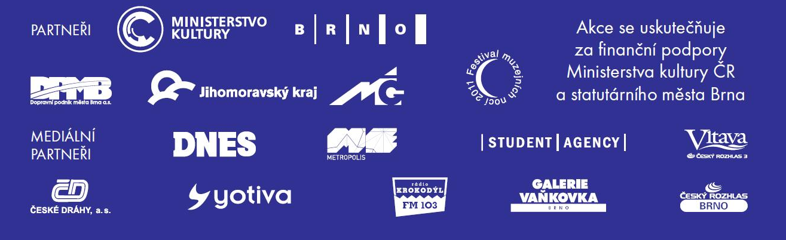

CONTACT FOR MEDIA:
Martina Vašková, marketing and communication, +420 724 516 672, +420 532 169 174
tisk@moravska-galerie.cz

